Mission  We will service the communities by providing women with purpose, direction and motivation to help us accomplish our mission and improve our organization. We will enlighten, encourage and empower all women that are connected with the military or federal government, to establish and maintain a lifelong sisterhood and bond, for charitable, societal, educational, and other non-profit purposes, for the greater good of the world.  ​  Vision  To ensure that every woman associated with the military is connected with adequate resources so that military affiliated women of all backgrounds and diversities can stand independently on their own and have a lifelong ability to continuously reach beyond the stars.  Motto  “She speaks with wisdom, and faithful instruction is on her tongue. Proverbs 31:26 | Frequently Asked Questions  What makes this organization different from other military sororities?  ΙΓΨ is the 1st and only military sorority that is open to all women affiliated with the military. Membership is not limited to active duty, retired or military spouses.  What is the minimum age to join?  For insurance purposes, all members must be at least 21 years of age or older.  How often does this organization have a line?  ΙΓΨ conducts 2 lines per year during the Spring and Fall.  I do not live in North Carolina. Can I still complete an application and join?  Yes, we also have Sorors in South Carolina, Georgia, Alabama, Virginia, Maryland and Colorado  What if I don’t live in any of those states, can I still join?  Yes, we are growing and hope to create a location where you are.  What types of community service does ΙΓΨ perform?  We perform all sorts of community service. A few include feeding/clothing the homeless and less fortunate, food bank assistance, disaster relief efforts, assist with habitat for humanity efforts and more.  How do I join?  Register for access, complete the application, submit application fee, interview and complete the development program.  How can I find out more information about this sorority?  Please monitor our social media pages for info on Interest Meetings or for more information, please email one of our membership recruiters at recruiter@iotagammmapsi.com |  | Iota Gamma Psi Military Sorority Inc.  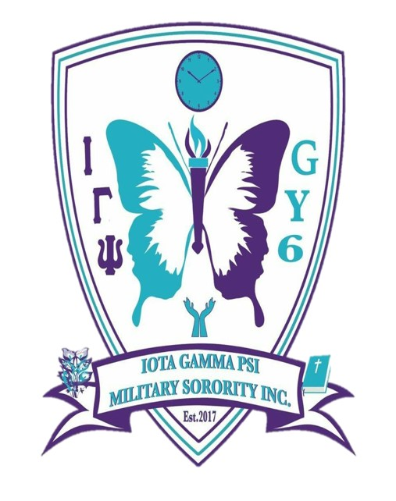  Founded August 16, 2017 and incorporated December 5, 2017 as a 501(c)3 non-profit organization, Iota Gamma Psi (ΙΓΨ) Military Sorority Incorporated is a military affiliated, non-collegiate, social and community-service sisterhood.  ΙΓΨ offers workshops and training on leadership, team building, financial management, resume building, confidence building, stress management, health education, career development and a host of other things.  When you are marked for distinction, it means that you are someone who is going to do very well in life. You will set yourself apart from others in many ways through your actions. You will set the standards! Are you a Woman of Distinction? If so, ΙΓΨ may be the place for you. We encourage all eligible women to learn more about joining our organization.

Core Initiatives  ​​ΙΓΨ’s Destined to Be Diamond (D2BD) is a program that is designed to provide all Sorors with a journey that will ENLIGHTEN, ENCOURAGE and EMPOWER them as women. We aim to establish a lifelong sisterhood that is built on love and continuous mentorship. One of our goals is to empower our members to speak with wisdom according to Proverbs 31:26. We will assist them by providing them with the necessary tools that will help them to develop their skills and ability to accomplish and sustain their goals in life.  ​ΙΓΨ H.E.W (Health, Education & Wellness) is a program geared towards educating women on health concerns. We offer Philanthropic Service to others that promote learning and education while also providing moral support and tips that will help others that may be dealing with a health concern. Some of these opportunities may include: National Glaucoma Awareness, National Heart Healthy, Cancer Awareness, National Developmental Disabilities Awareness, National Autism Awareness and much more.  ​ΙΓΨ Diamond Mentorship Program was designed to develop chapter champions that will serve as Mentors and provide a mechanism for developing future leaders. We aim to promote individual development through the transfer of skills, expert knowledge and insight, and provide an additional resource for feedback and guidance that will help with Soror involvement satisfaction and retention. Iota Gamma Psi Diamond Mentorship Program strives to excel at mentoring new members of the sorority by establishing a two-to-one volunteer pairing of Mentees with a volunteer Mentor.  ΙΓΨ Baby K.A.R.A.T.S (Kimberlite Apprentice Reaching Achievable Targets) ​A Kimberlite is an igneous rock, which sometimes contain diamonds. ΙΓΨ’s Baby K.A.R.A.T.S program focuses on mentoring high school young ladies in grades 9-12 and is designed to empower and encourage positive self-image, high scholastic standards, financial responsibility, community involvement, and social skills. | Core Initiatives  ΙΓΨ’s Women's Ministry Coalition (WMC) is not affiliated with any political party or religious denomination. We welcome and invite all of our sisters to join our women’s ministry coalition to unify and give voice to religious, social, cultural, moral and public policy issues of our day. This will give us the ability as women to work together to promote the values of Faith and Family. ΙΓΨ’s WMC is composed of women of faith and conviction, working together to support and serve women. Our primary goal is to minister to the spiritual needs of women and to help women to KNOW and WALK in their PURPOSE.  ​ΙΓΨ M.S.P (My Sister’s Protector) ​ΙΓΨ is more than just a sorority, it is a life-long commitment and sincere friendship rooted in kindness, love and respect for one another. We are our sister’s protector. There we stand firm in our belief and use of phrase, "WGY6" because we will always have our sister’s back. MSP will ensure that we support our Sorors unconditionally. When life blindsides them with undesirable events, we will be there for them without complaint, supporting them in their moment of need, not for our own selfish, self-gratifying reasons, but because their well-being will always be important to us. We will never disrespect our sisters and our words will always match our behaviors and actions.  ​ΙΓΨ Women of Distinction nurtures the qualities of strong character that distinguish our members and our sisterhood, including compassion, integrity and sincerity. In ΙΓΨ, members lead by example through their daily actions and communication. They set high expectations and goals and strive diligently to meet them. We accomplish this task by helping each other to grow personally and intellectually. Members of ΙΓΨ also believe in Paying It Forward so that those members that come after them, can benefit from their legacy and the difference that they made. | Eligibility  Are you eligible to join the Women of Distinction? Any woman who is honorably serving or has served in the United States Armed Forces, a spouse of a service member that is honorably serving or has honorably served in the United States Armed Forces, United States Federal Civil Service women (active & retired) or a current Government contractor (with verifiable proof) is eligible to apply for membership. We accept women from all branches of service: Army, Navy, Air Force, Coast Guard, and Marines. We also accept former Military Greek Letter sorority members that left in good standing.  Contact Us  Iota Gamma Psi Military Sorority Inc.  Ph: (803) 403-4814  Email: membership@iotagammapsi.com  Website: www.iotagammapsi.org  Locations  North Carolina South Carolina  Georgia Alabama  Virginia Maryland  Coming soon to other locations

